Designing Impact: Insights into Effective UX Research Portfolios
Learning About Users Formal Report

Executive summary
This report examines the expectations, content preferences, aesthetic considerations, and usability challenges of digital UX research portfolios. It is designed for UX researchers, designers, and students hoping to enter the field seeking to understand the elements that contribute to a successful portfolio. The study employed a mixed-methods approach, incorporating survey responses from 19 participants and semi-structured interviews with early-career UX professionals. The research aimed to identify the most critical best practices of portfolio presentation, including case study informational structure, visual storytelling, web navigation, and overall design aesthetics and what they communicate to the user.

The findings emphasize that clarity, structured storytelling, dynamic design, and impact-driven content are the most important factors in a strong research portfolio. Hiring professionals prioritize well-structured case studies that highlight research findings and impact, with 90% of respondents stating that clearly presented research impact is the most influential factor in hiring decisions. Additionally, users strongly prefer visual storytelling, such as infographics, images, and structured layouts, over text-heavy content. Navigation and usability also play a key role—80% of users cite excessive text as a major frustration, while 60% struggle with unclear navigation.

The report highlights common usability challenges, including poorly organized content, excessive academic jargon, and cluttered design aesthetics, all of which can diminish a portfolio’s credibility. The most highly supported recommendation is to use a structured case study format, such as the STAR method (Situation, Task, Action, Results), combined with engaging visuals and intuitive navigation to highlight case studies and impact. By implementing these strategies, UX researchers can enhance the clarity, professionalism, and resonance of their portfolios, ensuring that they effectively communicate their expertise and stand out in a competitive job market.

Table of Contents
Executive summary 1
Introduction 2
Methodology 2
Findings 3
Recommendations 9
Conclusion 10
Appendix 1: Interview 11
Appendix 2: Survey 11
Appendix 3: Personna 11
Appendix 4: Journey Map 12

Introduction
This report examines the expectations, content preferences, aesthetic considerations, and usability challenges of digital UX research portfolios. It is intended for UX researchers, designers, and hiring professionals who seek to understand what makes a portfolio successful in showcasing research expertise. Using a mixed-methods approach that included survey responses from 19 participants and two semi-structured interviews, the study identifies key elements that enhance a portfolio’s effectiveness. Participants were primarily UX researchers and designers at 69%, with 44% being students, indicating a focus on early-career professionals. The study explores how hiring managers and industry professionals evaluate portfolios, what they prioritize in case studies, and how design aesthetics impact usability and credibility.

The findings suggest that clarity, storytelling, and impact-driven content are essential in a successful research portfolio. The results indicate that users favor structured case studies, strong visual storytelling, and intuitive navigation. Additionally, clear and concise research summaries, engaging design elements, and effective organization contribute to a portfolio’s success. The study also highlights common usability barriers, such as excessive text, poor navigation, and outdated aesthetics, which can undermine a researcher's credibility. This report provides actionable recommendations for improving UX research portfolios, including content structuring, visual hierarchy, and user-friendly design approaches to enhance engagement and professional impact.

Methodology
This study employed a mixed-methods approach, combining survey research and semi-structured interviews to identify trends in user expectations for digital UX research portfolios. The survey, conducted through Qualtrics, gathered responses from 19 participants, with a majority identifying as UX designers or UX researchers (69%), and a notable portion (44%) being students, indicating a respondent pool primarily in the early stages of their careers. 12% of respondents identified as anthropologists, demonstrating some disciplinary diversity. All participants had prior interaction with research portfolios, with 43% reviewing portfolios a few times a year and 36% doing so a few times a month, confirming that the sample had sufficient familiarity with portfolio evaluation. The survey incorporated multiple-choice questions, Likert scales, and open-ended responses, allowing for both quantitative trends and qualitative insights to emerge. Key areas of focus included preferred portfolio features, aesthetic styles, user expectations, and common usability barriers, with findings used to triangulate data from the interviews.

To complement the survey findings, two semi-structured interviews were conducted via Zoom with early-career professionals in UX research and UX design (1–5 years of experience). One interviewee was a UX designer with hiring experience, while the other was a UX researcher. These interviews provided exploratory insights into what professionals find engaging, relevant, and necessary in a research portfolio. The flexible format allowed for deeper probing into key content preferences, usability expectations, and definitions of a “successful” portfolio. The qualitative data from these discussions enriched the survey results, helping to contextualize user priorities and highlight potential design and content improvements for research portfolios.

Findings
This research identified key expectations, content preferences, aesthetic considerations, and usability challenges in research portfolios. The findings, drawn from survey responses and interviews, provide clear recommendations for creating an effective portfolio.

Users' Expectations for Research Portfolios
A dominant theme throughout the data is that users prioritize clear, structured storytelling that demonstrates research impact. Users are not just looking for research outputs but want to understand the significance of the work. A strong portfolio must communicate not only what was done but why it mattered in a structured, easy-to-follow format. The most critical elements include case studies demonstrating real-world outcomes and visual storytelling through images and infographics. These elements help users quickly assess the quality of the research and its applicability. Less essential but still valuable are personal background sections and testimonials, which add depth but should not be the primary focus.
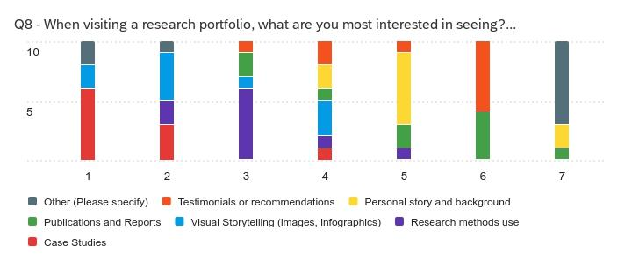
Brevity and clarity are highly valued, with 64% of participants preferring portfolios that provide both a summary and an option for more in-depth exploration. This supports the inclusion of a layered content approach, where key insights are presented upfront with an option to download a more detailed report. Recruiters, in particular, spend only 30 seconds to three minutes scanning a portfolio before deciding whether to explore further according to one Interview participant. Thus, the homepage and case study previews must immediately communicate the researcher's capabilities and impact. Users also appreciate things like interactive elements and downloadable reports, which allow for deeper engagement on their terms.
Additionally, all interview participants had been trained in anthropology, and 69% of survey respondents were at least moderately familiar with anthropology, recognizing its relevance to UX. This presents an opportunity for researchers to position themselves as outside-the-box thinkers by dynamically integrating anthropology into their portfolios. Creative design features that were preferred in the findings include a simple, engaging overview of anthropology, a section connecting anthropology to business, interactive elements linking research and anthropology, and testimonials from people who have benefited from the research. Successful portfolios should incorporate anthropology in an engaging and digestible way, ensuring it strengthens the researcher’s brand rather than overwhelming the audience with theory.

Key Content in a Successful Research Portfolio
A strong research portfolio must effectively communicate research insights through clear and structured case studies. The STAR method (Situation, Task, Action, Results) is a widely preferred framework, ensuring that the impact of research is emphasized.
Survey results show that hiring managers prioritize well-structured case studies that highlight impact, methodologies, and key insights. 90% of respondents stated that clearly presented research impact had the greatest influence on hiring decisions, with 80% citing engaging storytelling and well-organized layouts as critical factors. This confirms that it is not just about the research itself, but how well it is communicated. Users expect concise summaries with an option for deeper exploration, with 64% preferring a summary on the main page and an option to explore in-depth case studies.
In terms of content depth, users expect:
- A high-level overview of the research problem and methodologies.
- Moderate detail in findings and key takeaways.
- The most in-depth focus on impact and outcomes.
- Minimal detail in reflection sections, which should be concise but present.
- Little to no academic theory, unless clearly tied to practical applications.
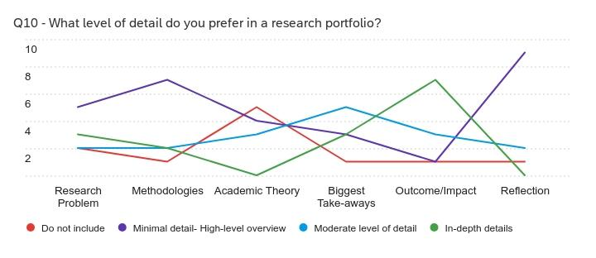
While some respondents acknowledged the importance of testimonials, personal background, and academic work, these elements were consistently ranked as less important compared to case studies and research impact. Users want to see proof of research capabilities through real-world examples rather than lengthy credentials or theoretical discussions. Furthermore, industry experience is generally more valued than academic projects, though concise demonstrations of anthropology’s relevance in applied research can enhance credibility. Users value storytelling that makes research findings engaging, and hiring professionals look for structured case studies that highlight research impact. Hiring managers and peers prioritize "proof of work" over credentials. A well-documented case study with measurable impact is significantly more persuasive than a long list of academic achievements or theoretical explanations.
To align with these expectations, portfolios should prioritize concise, structured content with clear takeaways. Providing a mix of high-level summaries with detailed downloadable reports ensures flexibility in how users engage with the material.

Aesthetic Preferences of Users
One of the most consistent patterns in the data is that users prefer portfolios that prioritize visuals over dense text, the visual design of a portfolio significantly influences how users perceive the researcher. A clean and modern layout is the most preferred style, with 50% of users favoring structured, intuitive designs and bold, vibrant colors that enhance credibility. Users also expect portfolios to feel up-to-date, as outdated or cluttered designs create negative assumptions about the researcher’s professionalism and experience. Specifically, 73% of users associate clear and simple layouts with strong professional competency, while 55% view a well-designed portfolio as a sign of being detail-oriented. Conversely, 45% of respondents assume that a disorganized or outdated portfolio reflects inexperience. A well-designed portfolio not only makes navigation easier but also shapes how users perceive the researcher’s skills and credibility.
Easy navigation is another crucial factor. While users expressed no strong preference between single-page scrolling and multi-page navigation, they emphasized that content must be well-organized and easy to find. Since 73% of users primarily access portfolios via desktop, the design should prioritize desktop-friendly UI elements while maintaining mobile responsiveness.
A portfolio’s design should also reflect an engaging and professional vibe. Users expect a balance between aesthetics and substance, with 100% of respondents stating that both strong design and meaningful content are essential. The most successful portfolios strike a balance between text and visuals, ensuring that information is digestible at a glance, reinforcing that even the best research is ineffective if it is poorly presented. Since portfolios serve as an indirect reflection of a researcher’s attention to detail, creativity and storytelling ability, their visual presentation should be polished, intuitive, and modern. To maintain credibility, it is recommended that researchers periodically update their portfolios with contemporary design elements.
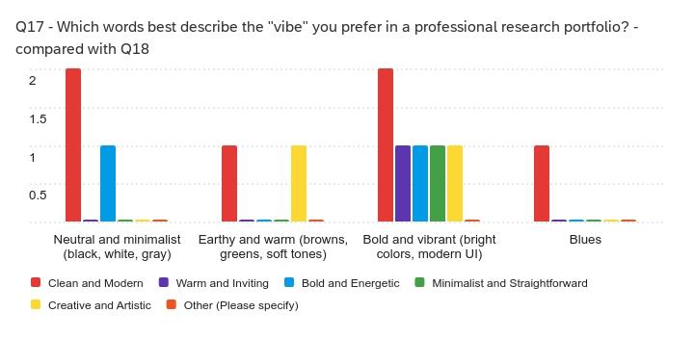

Common Usability Barriers in Research Portfolios
Several usability challenges can hinder the effectiveness of a research portfolio. The most significant frustration, cited by 80% of users, is excessive text. Lengthy descriptions and dense academic jargon make portfolios difficult to navigate and engage with. Instead, users prefer content that prioritizes visual storytelling, using infographics, process images, and data visualizations to convey information efficiently. Additionally, 60% of respondents identified difficult navigation and unclear organization as major barriers, emphasizing the need for a streamlined and intuitive layout.
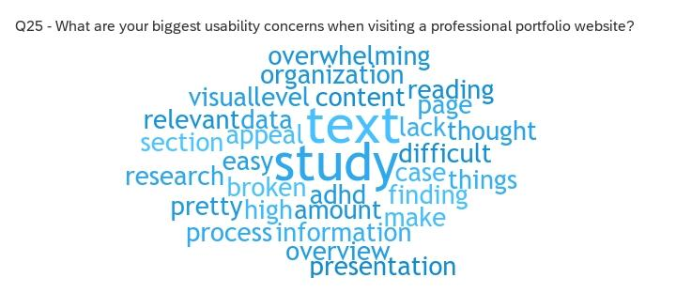
A poorly executed portfolio can work against the researcher by signaling inexperience. Forty-five percent of respondents noted that if a portfolio feels outdated or disorganized, they assume the researcher lacks expertise. This highlights the importance of keeping the portfolio well-structured, with content that is easy to scan and digest. Since hiring managers and other professionals spend only one to three minutes evaluating a portfolio, the homepage should provide a compelling first impression, drawing users into the researcher's work.
Another common issue is balancing content and design. Users overwhelmingly prefer portfolios that maintain an equilibrium between strong content and clean visuals. If a portfolio is too text-heavy, key insights may be lost, whereas an overly designed portfolio without substantial content can appear superficial. To address these issues, researchers should prioritize concise writing, intuitive navigation, and engaging visuals while ensuring the overall user experience is seamless.

Final Takeaways for an Effective Research Portfolio
Another strong pattern is that unclear navigation and disorganized layouts are major usability barriers. 60% of users reported that poor navigation and organization made portfolios frustrating to use, and both interview participants noted that if information isn’t easy to find, they quickly lose interest. To create a compelling research portfolio, it is essential to focus on well-structured case studies that clearly communicate impact. The use of visual storytelling elements—such as infographics, screenshots, and process images—can enhance comprehension while minimizing excessive text. A clean and modern design with intuitive navigation ensures a positive user experience and helps build credibility. It is also crucial to balance aesthetics with meaningful content, as hiring professionals prioritize portfolios that demonstrate clear research thinking, structured methodologies, and engaging storytelling.
The most effective portfolios highlight a mix of academic and applied research without relying heavily on jargon. Users also appreciate interactive features, downloadable reports, and case study summaries that allow them to engage at different levels of depth. Avoiding common mistakes—such as disorganized layouts, outdated designs, and excessive academic theory—ensures that the portfolio effectively communicates the researcher’s skills and expertise.
Ultimately, a strong research portfolio should not only showcase past work but also serve as a dynamic representation of the researcher’s ability to think critically, present findings clearly, and deliver impactful insights. By focusing on clarity, storytelling, and usability, researchers can create portfolios that resonate with both hiring managers and professional peers.

Recommendations
Based on the survey and interview data, the following recommendations will help create an effective and impactful research portfolio.

Content & Structure
- Prioritize Case Studies with Impact – Clearly present research outcomes, using the STAR method (Situation, Task, Action, Results) to structure case studies.
- Use a Layered Content Approach – Provide a brief summary of each project with an option to explore more details, such as a downloadable PDF for deeper insights.
- Balance Academic and Industry Work – While industry work is more valued, academic research should be included if it is concise and directly applicable to real-world work.
- Highlight Mixed Methods & UX Case Studies – These are the most compelling research types, favored by 64% and 82% of respondents, respectively.
- Minimize the Use of Academic Jargon – Keep descriptions clear, concise, and engaging to ensure accessibility.
- Showcase Visual Storytelling – Use infographics, images, and process visuals to communicate complex information quickly and effectively.
- Provide Reflection Sections Briefly – Users appreciate insight into lessons learned, but reflections should remain concise.

Design & Aesthetics
- Ensure a Clean, Modern Layout – 50% of users prefer structured, intuitive designs that are easy to navigate.
- Use Bold, Vibrant Colors Strategically – These are associated with credibility and professionalism while keeping the site visually engaging but avoid looking cluttered.
- Avoid Cluttered or Outdated Designs – A disorganized portfolio hurts credibility, with 45% of respondents assuming an outdated site signals inexperience.
- Ensure Mobile Responsiveness, but Prioritize Desktop – 73% of users primarily access portfolios via desktop.

Navigation & Usability
- Make Navigation Intuitive and Seamless – Users must find what they need quickly; difficult navigation is a major frustration (60% of respondents).
- Reduce Excessive Text – 80% of users cite too much text as a major frustration; prioritize visuals with minimal, high-impact text.
- Ensure Visual Hierarchy – Key information should stand out clearly, avoiding blocks of dense text.
- Balance Content and Design – 100% of users prefer a balance between strong content and good design for maximum impact.

Engagement & Professionalism
- Use Engaging Storytelling Techniques – A compelling research portfolio should connect with the audience and be easy to understand.
- Keep the Portfolio Updated – Users associate outdated designs with inexperience; refresh visuals and content periodically.
- Make a Strong First Impression – 70% of users decide within 1-3 minutes whether the portfolio is relevant, so ensure key strengths are immediately visible.

By following these recommendations, researchers can create an effective and engaging portfolio that clearly communicates their expertise, showcases their impact, and provides a seamless user experience.

Conclusion
This report examined the expectations, content preferences, aesthetic considerations, and usability challenges of digital UX research portfolios. By analyzing survey responses from 19 participants and conducting two semi-structured interviews, the study identified key factors that contribute to an effective portfolio. Participants were primarily UX researchers and designers (69%), with a significant portion being students (44%), reflecting the needs of early-career professionals. The findings underscored the importance of clear and structured case studies, engaging visual storytelling, and intuitive navigation in creating a compelling portfolio. Elements such as concise research summaries, well-organized layouts, and modern design aesthetics played a crucial role in shaping user perceptions of credibility and professionalism.

The results suggest that a research portfolio should prioritize impact-driven storytelling, balance strong content with clean design, and maintain a user-friendly experience. Excessive text, poor navigation, and outdated layouts emerged as common usability barriers that hinder engagement and credibility. The most highly supported recommendation from both survey and interview data is to adopt a structured case study format (such as the STAR method) and incorporate visual storytelling elements to make research findings accessible and engaging. By implementing these strategies, UX researchers and designers can create portfolios that effectively showcase their expertise, resonate with hiring professionals, and establish a strong professional presence in the field.

Appendix 1: Interview
Demographics
What do you do?
How long have you done it?

Questions
- What is the context in which you find yourself looking at portfolios?
- What content do you search for first in a portfolio?
- What on average is your favorite part of a research portfolio?
- What makes you like it?
- Can you describe a portfolio that left a strong impression on you? What made it stand out?
- If you could give one tip to a new professional in your field building their first research portfolio, what would it be?

Additional questions to prime answers
- Have you ever dismissed a portfolio quickly? What made you decide it wasn’t relevant or strong enough?
- What is one thing you wish more portfolios did differently?
- What is one thing you think the majority of portfolios get wrong?

Link to Interview Findings

Appendix 2: Survey
Link to the Survey

Link to Survey Results

Appendix 3: Personna
Link
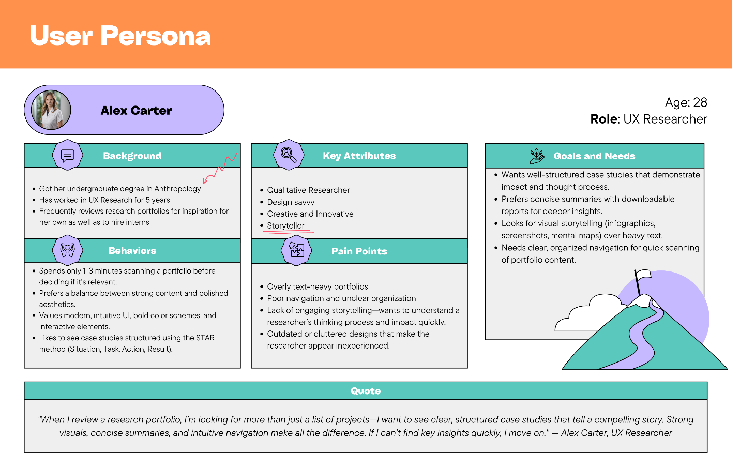

Appendix 4: Journey Map
Link

