Optimizing Usability: A User-Centered Evaluation of a Research Portfolio Website
Learning About Users Formal Report

Executive Summary
This report evaluates the usability, readability, and navigability of a research portfolio website through a combination of usability testing methods, including Moderated Think-Aloud Protocol, Card Sorting, and Heuristic Evaluation. The primary objectives were to determine whether key information such as case studies, methodologies, and findings were easy to locate, assess the readability and clarity of the content, evaluate the site’s perceived professionalism, and ensure alignment with intended branding and messaging.
The findings revealed significant usability challenges. Users struggled with navigation due to unclear information architecture and inconsistent labeling, leading to difficulty in locating critical content. The visual design, including a dark color palette, low contrast, and distracting animated background elements, negatively impacted readability and engagement. Additionally, inconsistent formatting within case studies and ambiguous terminology reduced the site's professional credibility.
To address these issues, the report provides actionable recommendations, including improving navigation with breadcrumb trails and clearer menu labels, enhancing readability through higher contrast and better text hierarchy, standardizing case study organization, and using intuitive language for site elements. Additionally, the report suggests simplifying the visual design by removing distracting elements and optimizing the homepage to present the researcher’s expertise more effectively.
The System Usability Scale (SUS) score of 56.67 indicates that the site's usability falls below industry standards, reinforcing the need for improvement. Implementing these recommendations will enhance user experience, improve engagement, and strengthen the researcher's professional credibility. Future usability testing and iterative improvements are essential to ensure the portfolio effectively meets user expectations and communicates the researcher’s expertise in a clear and compelling manner.
Executive Summary 1
Introduction 2
Methodology 2
Findings 3
Navigation and Information Architecture 3
Figure 1: Card Sort Dendrogram 4
Visual Design and Readability 4
Labeling and Terminology 5
Content Organization and Presentation 5
Perceived Professionalism and Trustworthiness 5
System Usability Score (SUS) and Overall Usability 6
Recommendations 6
Navigation & Information Architecture 6
Visual Design & Readability 6
Content & Labeling 7
Usability & User Experience Enhancements 7
Professionalism & Credibility 7
Future Improvements 7
Conclusion 7
Appendix 1: Link to Website that was Evaluated 8
Appendix 2: Methodological tools Used 8
Appendix 3: Results of Data Collection 8

Introduction
The purpose of this research assessment is to evaluate the strengths and weaknesses of a research portfolio, understand user expectations, identify problems encountered by users, and determine how modifications to the site can enhance usability and alignment with user needs. This report evaluates the usability, readability, and navigability of a research portfolio website through a combination of usability testing methods, including a Moderated Think-Aloud Protocol, Card Sorting, and Heuristic Evaluation. The study aims to assess whether users can efficiently locate key information, understand the content structure, and engage with the site in a way that supports its intended purpose. By gathering qualitative and quantitative insights from users and experts, this research provides a comprehensive analysis of the site's strengths and areas for improvement.
This research focuses on four key objectives: (1) evaluating whether key information, such as case studies, methodologies, and findings, is easy to locate; (2) assessing whether the content is presented in a way that is easy to read and understand; (3) evaluating how trustworthy and professional the site appears to users; and (4) determining whether the site design aligns with the intended branding and messaging.
The findings highlight several critical usability challenges, including poor navigation structure, unclear labeling and terminology, distracting visual design elements, and inconsistent content organization. Additionally, the site’s current design choices negatively impact readability and overall professionalism. Based on these insights, this report presents actionable recommendations to enhance the user experience, improve content clarity, and create a more intuitive and visually appealing research portfolio.

Methodology
This research study employed a combination of usability testing methods to evaluate the effectiveness, readability, and navigability of a research portfolio website. The study utilized Moderated Think-Aloud Protocol, Card Sorting, and Heuristic Evaluation to gain both qualitative and quantitative insights into user behavior, expectations, and challenges while interacting with the site. Data collection was conducted remotely through Zoom and the Proven by Users platform, and the heuristic evaluation utilized Jakob Nielsen’s Ten Usability Heuristics for User Interface Design.
The Moderated Think-Aloud Protocol involved three participants, including a UX design student, a biochemist, and a civil engineer, who completed structured usability sessions over Zoom. Each participant was asked to complete a series of tasks while verbalizing their thoughts, impressions, and difficulties encountered, allowing for an in-depth assessment of navigation challenges, task completion difficulties, and overall user experience. Card Sorting was conducted using Proven by Users, where five participants completed a hybrid sort exercise to evaluate how they expected information to be categorized and structured on the website. This method helped uncover user mental models, highlight confusion points, and inform improvements to the site’s information architecture. Additionally, an Expert Heuristic Evaluation was performed using Jakob Nielsen’s Ten Usability Heuristics for User Interface Design to systematically review the portfolio for usability issues. The evaluator identified design inconsistencies, accessibility barriers, and key usability violations, which were rated in severity and mapped to specific recommendations for improvement.
The combination of these methodologies provided a well-rounded assessment of the research portfolio’s usability. The Think-Aloud Protocol provided real-time user insights, Card Sorting helped refine content organization, and Heuristic Evaluation identified structural and usability deficiencies. Collectively, these methods offered a deep understanding of how users navigate the site, perceive its usability, and engage with its content, leading to actionable recommendations for improvement

Findings

Navigation and Information Architecture
One of the most significant usability issues identified across all methods was poor navigation and unclear information architecture. Users struggled to locate key content, such as case studies, methodologies, and findings, due to inconsistent labeling and a lack of logical structure. The heuristic evaluation and card sorting exercise, illustrated in Figure 1 below, highlighted that critical elements like the "Portfolio" button were misleading, and users were unsure of where to find case study information. Additionally, the lack of clear indicators of a user's current location within the site made navigation confusing.
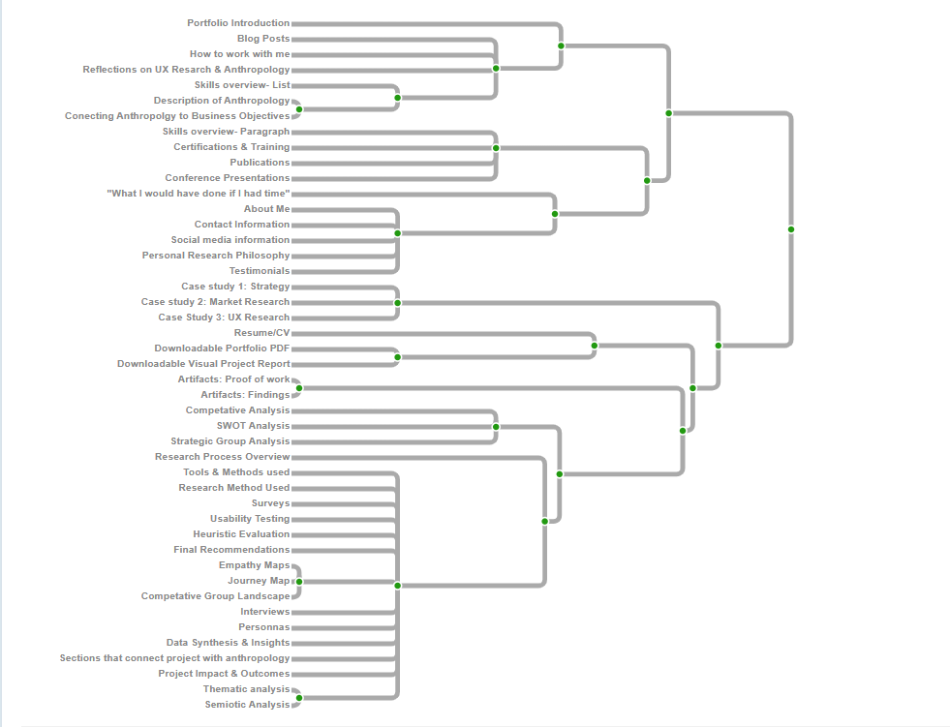

Figure 1: Card Sort Dendrogram
Recommendation: Introduce breadcrumb navigation, improve menu labeling for clarity, and create a more structured categorization of research content. Implementing clear section headings and ensuring uniformity in case study presentation will enhance usability.

Visual Design and Readability
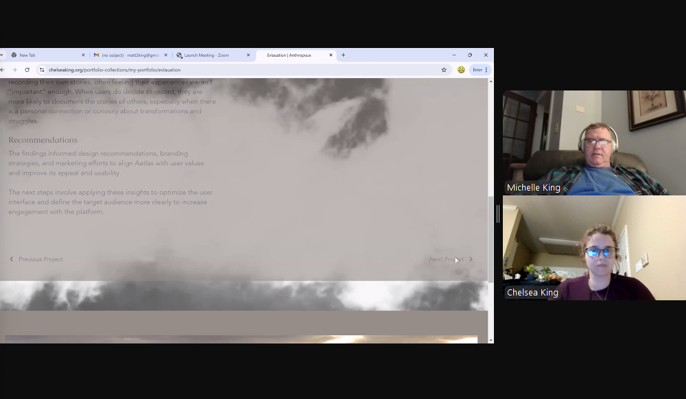
The site’s visual design was found to be distracting and not conducive to readability. The dark color palette, low contrast, and moving background elements (e.g., animated smoke) made it difficult for users to focus on content. Additionally, small text size and inconsistent formatting further impeded readability. These findings were consistent across the think-aloud tests and heuristic evaluation, where participants expressed frustration with the overwhelming design choices.
Recommendation: Simplify the visual design by removing distracting background elements, increasing text size, and ensuring sufficient contrast between text and background. A more contrasting and bright color palette will improve readability and overall user experience.

Figure 2: Screenshot of distracting design

Labeling and Terminology
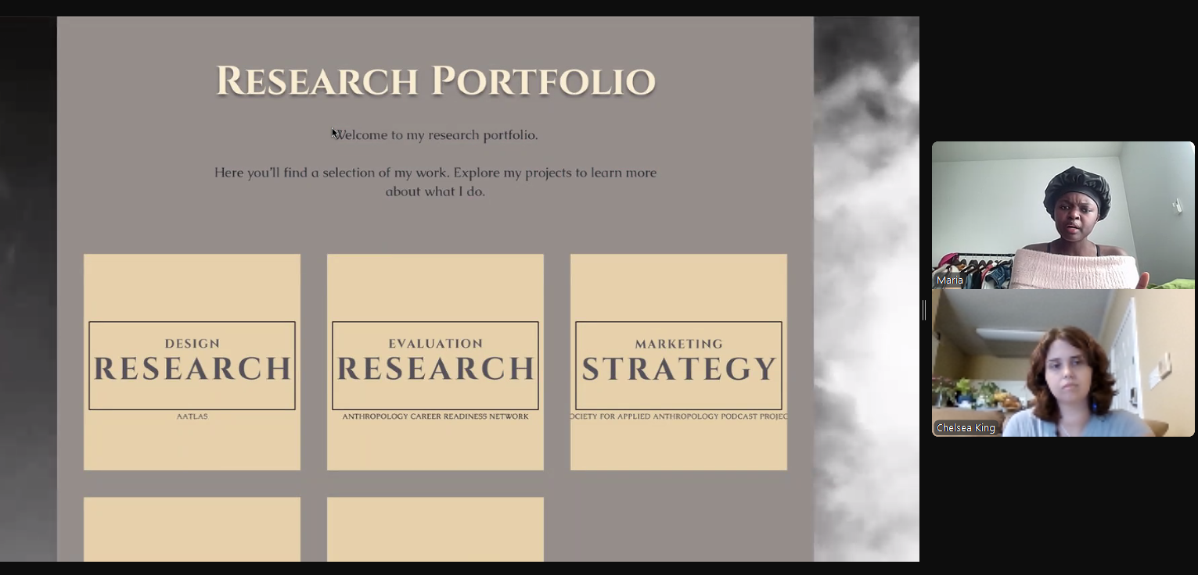
The terminology used throughout the site did not align with users’ expectations, making it difficult for them to find relevant information. The card sorting results showed that users expected information to be categorized in a more intuitive manner, while the usability tests confirmed that ambiguous labels (e.g., "Portfolio" instead of "Home", or “Evaluation Research” instead of the Client name, as shown in Figure 3) led to confusion. Additionally, research categories were not clearly defined, making it challenging for users to distinguish between different case studies.

Figure 3: Screenshot of confusing terminology

Recommendation: Use user-friendly and familiar terms for navigation labels. Replace ambiguous terminology with industry-standard or intuitive language (e.g., "Case Studies" instead of category-based titles). Ensure all categories and sections are clearly labeled and structured consistently across the site.

Content Organization and Presentation
Users found the organization of content within case studies to be inconsistent and difficult to follow. In particular, participants struggled to determine whether information was a continuation of previous sections or a separate topic due to poor paragraph structure and layout. The heuristic evaluation reinforced this, identifying a lack of standardization across case studies, which contributed to user confusion.
Recommendation: Establish a consistent format for case studies, including clearly defined sections for methodology, findings, and impact. Use bold headings and visual separation to make content easier to scan. Ensure a logical flow of information to minimize cognitive load.

Perceived Professionalism and Trustworthiness
Link to video of Landing page
Despite strong content, users perceived the site as less professional due to its design and structural inconsistencies. The combination of distracting visuals, unclear organization, and inconsistent formatting reduced the credibility of the researcher. Participants in the think-aloud tests expressed concerns that a potential hiring manager or client might view the site as disorganized and difficult to navigate, which could negatively impact their impression of the researcher’s expertise.
Recommendation: Improve the site’s overall aesthetic by refining layout consistency, removing unnecessary visual distractions, and optimizing information presentation. Ensuring a polished and professional look will enhance credibility and user trust.

System Usability Score (SUS) and Overall Usability
The usability testing resulted in an average SUS score of 56.67 with a 95% confidence interval ranging from 41.04 to 72.30, indicating that the site's usability is below industry standards (a score below 68 is considered below average). This finding reinforces the need for structural, visual, and functional improvements to enhance user experience and engagement.
Recommendation: Addressing the key usability issues outlined above—navigation clarity, improved visual hierarchy, content restructuring, and terminology refinement—will help increase usability and ensure a smoother user experience.

Recommendations

Navigation & Information Architecture
- Implement Breadcrumb Navigation – Helps users track their location within the site and navigate more easily.
- Rename "Portfolio" Button to "Home" – Aligns with user expectations and eliminates confusion.
- Standardize Case Study Organization – Use a clear and consistent structure for all case studies, including labeled sections for methodology, findings, and impact.
- Reduce Click Depth – Ensure that key content is accessible within a minimal number of clicks.

Visual Design & Readability
- Increase Contrast and Readability – Adjust text size, use a higher contrast color palette, and replace the dark background with a more neutral one.
- Remove Distracting Visual Elements – Eliminate or slow down animated smoke in the background to prevent distraction.
- Use a More Professional and Cohesive Color Scheme – Limit the number of colors and maintain a visually balanced design.

Content & Labeling
- Use Intuitive Labels for Navigation – Replace ambiguous terms with more familiar ones (e.g., “Case Studies” instead of broad category-based names).
- Ensure Consistency in Terminology – Align naming conventions across the site to reduce confusion.
- Highlight Key Information Clearly – Use bold headers and text formatting to make important details (e.g., methodologies and findings) easy to find.

Usability & User Experience Enhancements
- Improve Call-to-Action (CTA) Visibility – Ensure buttons like “Contact” and “Work With Me” are easily accessible and stand out.
- Simplify the Footer & Remove Redundant Elements – Minimize unnecessary information to keep the focus on essential content.
- Improve Button Placement & Design – Make “Back,” “Next,” and “Home” buttons more visible and accessible at the top and bottom of case study pages.

Professionalism & Credibility
- Refine Homepage Introduction – Clearly state the researcher’s expertise and value proposition upfront.
- Ensure Consistency in Formatting – Maintain uniform alignment, spacing, and text organization across all pages.
- Reduce Unnecessary Content – Remove sections like the "Content Library" if they do not add value.

Future Improvements
- Conduct Additional User Testing – Validate changes by testing new iterations of the site with users to ensure enhancements are effective.
- Use Analytics to Track User Behavior – Implement tracking tools to understand how users interact with the site and make data-driven adjustments.

Conclusion
This report assessed the usability, readability, and navigability of a research portfolio website using a combination of usability testing methods, including Moderated Think-Aloud Protocol, Card Sorting, and Heuristic Evaluation. The study aimed to evaluate whether key information such as case studies, methodologies, and findings were easy to locate, determine if content was presented in a clear and comprehensible manner, assess the site's trustworthiness and professionalism, and ensure alignment with intended branding and messaging.
The findings revealed several key usability challenges, including unclear navigation and information architecture, inconsistent labeling and terminology, distracting visual elements, and poor content organization. These issues significantly impacted the user experience, making it difficult for users to efficiently engage with the content and form a positive impression of the researcher’s expertise. Additionally, the System Usability Scale (SUS) score of 56.67 indicates that the site's usability falls below industry standards, reinforcing the need for improvements.
To enhance the site's usability and overall user experience, this report recommends implementing clearer navigation structures, improving visual contrast and readability, standardizing case study formatting, and using intuitive labeling that aligns with user expectations. Addressing these areas will not only improve accessibility but also strengthen the site's professional credibility and engagement.
It is recommended that the research portfolio be redesigned with a user-centered approach, ensuring that all adjustments are guided by usability principles and best practices. Future iterations of the site should be tested with users to validate improvements and ensure an optimal experience. By implementing these changes, the portfolio can effectively communicate the researcher's expertise and make a lasting, positive impression on its audience.

Appendix 1: Link to Website that was Evaluated
Link to Website

Appendix 2: Methodological tools Used
Link to card sort
Think Aloud protocol
Link to SUS survey
Link to Heuristics used

Appendix 3: Results of Data Collection
Link to Card sort Results
Link to Think aloud Results
Link to Heuristic Review

