Gym App Ecosystem Analysis
Prepared by: Chelsea King, Applied Anthropologist & UX Researcher
Date: 3/16/2025

Executive Summary
The gym app ecosystem is highly competitive, with trust as a key factor in user engagement, retention, and brand differentiation. This report examines how different fitness apps build and maintain trust, categorizing them into three primary types: data-driven performance optimization apps, which rely on AI, biometric data, and wearables; science-based workout structuring apps, which emphasize expert-backed methodologies but often lack engagement; and community & lifestyle-oriented apps, which foster motivation through social features but risk competitive toxicity and over-marketing.
Despite advancements in fitness technology, gaps remain. Many apps struggle with AI adaptability, limiting their ability to evolve with user progress. Wearable integration is often exclusive to Apple Watch, excluding Android and alternative trackers. Furthermore, while social engagement drives motivation, poorly managed leaderboards and rankings can discourage users rather than inspire them.
To differentiate in this market, fitness apps must go beyond simple tracking and guided workouts by integrating learning, fun, and—most importantly—community. In today’s digital world, people crave connection and belonging, making a thriving, positive fitness community the ultimate key to success. Apps that foster healthy, engaging social environments while maintaining scientific credibility and AI-driven personalization will have a competitive advantage.
To build trust and long-term engagement, companies should focus on adaptive AI, expanded wearable compatibility, and community-driven engagement that balances competition with support. Offering educational content and gamified experiences will further deepen user investment. By prioritizing trust, personalization, and community-building, fitness apps can boost retention, increase user satisfaction, and create a sustainable market presence.

Gym App Ecosystem Analysis 1
Executive Summary 1
Introduction 2
The Gym App Landscape 3
What is Trust and Why It Matters 3
3. Competitive Landscape: Categorizing the Gym App Market 4
Category 1: Personal Data-Driven Performance Optimization Apps 4
Category 2: Science-Based Workout Structuring Apps 6
Category 3: Community & Lifestyle-Oriented Apps 7
How Trust is Established in Gym Apps 8
Market Gaps & Competitive Opportunities 9
Recommendations 10
Where to start: 10
Evaluation Grading System 11
Conclusion & Next Steps 13
Appendix #1: Persona for Personal Data-Driven Performance Optimization Apps 14

Introduction
Purpose of the Report:
This report evaluates the current gym app ecosystem, focusing on how different types of fitness apps establish trust with users and retain engagement. The fitness app market is saturated, yet many apps fail to build lasting trust with users. Trust directly impacts engagement, retention, and willingness to pay for subscriptions. Given the crowded market, understanding how trust impacts user retention and satisfaction and understanding how apps build and maintain trust helps identify opportunities and provide actionable insights for differentiation.
Key Findings:
- Gym apps fall into three main categories:
  - Data-Driven Performance Optimization Apps – Trust through AI, biometric data, and wearables.
  - Science-Based Workout Structuring Apps – Trust through evidence-based fitness plans.
  - Community & Lifestyle-Oriented Apps – Trust through social engagement and motivation.
- Biggest Market Gaps include:
  - Lack of cross-platform integration beyond Apple Watch.
  - Weak AI long-term personalization.
  - Balancing competition vs. community support to encourage motivation without discouragement.

The Gym App Landscape

What is Trust and Why It Matters
Trust is the confidence users place in an app’s ability to help them achieve their fitness goals effectively and reliably. Trust is built through consistent performance, transparency, accuracy, and user engagement, ensuring that individuals feel confident in the guidance provided.
In the context of gym apps, trust is critical because:
- Users rely on apps for health and fitness recommendations, meaning credibility and reliability directly impact adherence.
- Many fitness apps use AI and automation, requiring users to believe in the accuracy and safety of automated guidance.
- Long-term engagement is driven by how much users trust the app’s ability to deliver results, ensuring retention and customer satisfaction.
Methodology:
The evaluation incorporated qualitative content analysis from multiple data sources to create a competitive analysis of a group landscape:
- Marketing Materials: Social media advertisements were examined to understand how the brands construct public messaging and credibility.
- User Reviews: Publicly available user reviews from YouTube, blogs, and app store platforms were analyzed to assess first hand user experiences and trust-related themes.
- Platform Usability & Features: The app’s functionality, including workout structure, team engagement, and feedback mechanisms, was evaluated to determine how in-app experiences support or hinder trust.
- Competitive & Market Context: Strategies were compared to industry competitors to identify unique trust-building mechanisms.
Ecosystem Criteria
All the apps analyzed in this report offer some form of gym guidance without integrating one-on-one personal training with a live coach. While some provide access to human feedback through chat or support features, their core experience is based on science-driven, AI-generated, or pre-recorded workout guidance, allowing users to follow structured programs independently.

3. Competitive Landscape: Categorizing the Gym App Market
The market divides into three overarching key categories, each with distinct approaches to building trust.

Category 1: Personal Data-Driven Performance Optimization Apps
Example Apps: Athlytic AI, FitBod, Fitness AI, Workout Trainer AI
- Trust-Building Strengths
  - Credibility: Users trust data-driven insights because they rely on biometric tracking and predictive health monitoring. Apps emphasize data accuracy, often referencing research or AI models.
  - Trusted tech integration: Syncs with Apple Watch, Fitbit, Oura Ring, which reassures users that they are getting validated, high-quality data.
  - AI-driven personalized insights: Predictive analytics for stress, recovery, and sleep provide individualized recovery and performance insights, making users feel like the app truly understands them.
  - Transparency in metrics: Showing users how data is collected (e.g., heart rate variability, sleep cycles) reassures them that the insights are based on real data rather than arbitrary advice.
- Challenges & Weaknesses
  - Over-reliance on limited AI: If AI-generated recommendations don’t evolve effectively (e.g., Fitness AI’s generic progressive overload), users may lose faith in the technology.
  - Device exclusivity: Apps that only work with certain product ecosystems alienate users with other wearables. Ex, Apple Watch-only features exclude non-Apple users.
  - Too Data Driven: Some users may feel overwhelmed by too much tracking, leading to trust issues if the app’s insights conflict with their personal experiences and preferences and has limited ability to manually change.
Market Opportunity
- Improve personalization beyond generic AI models that include personal data.
- Expand cross-platform support to include a variety of wearable trackers including new technologies.
- Allow for manual personalization.

Category 2: Science-Based Workout Structuring Apps
Example Apps: BodBot AI, Workout Trainer AI, Coachify
- Trust-Building Strengths
  - Evidence-based training: Apps emphasize that workouts are science-backed, using research rather than trends to determine optimal routines. Apps like BodBot AI clearly state their algorithms are based on scientific principles rather than AI guesswork.
  - Education included with programs: Providing in-depth blogs, tooltips, or guides (e.g., BodBot AI’s science blog) reinforces credibility and positions the app as an authority.
  - Structured progression: Users trust these apps when they can see data-driven improvements and clear explanations of why certain exercises are chosen and can see clear milestones and improvements.
- Challenges & Weaknesses
  - Dull or Impersonal UI: Many apps feel clinical and uninspiring (dry UI, minimal gamification). While BodBot AI is highly science-driven, its lack of engaging visuals and community features may make it feel too robotic.
  - Lacks the human element for users to connect too: Users can’t adjust workouts dynamically and prioritize technical explanations over community building..
  - Struggles with personalization: Less adaptation for individual preferences. Apps like Coachify rely on "science-based" claims but fail to adapt to individual needs, making users doubt its effectiveness.
Market Opportunity
- Combine science-based credibility with engaging UX (gamified learning, interactive coaching, community building).
- Improve AI-driven adaptations for real-time adjustments.

Category 3: Community & Lifestyle-Oriented Apps
Example Apps: Workout for Women, Ladder, FitBod, Fitness AI
- Trust-Building Strengths
  - Social proof & community engagement : Apps use leaderboards, badges, and community sharing to show users that others are successfully using the app.
  - Cultural relatability: Meme marketing and fitness influencer partnerships create familiarity and cultural relevance (FitBod, Fitness AI), female-coded UI (Workout for Women addresses specific concerns like postpartum fitness). Some apps mimic the language of fitness subcultures (e.g., Coachify’s bodybuilding-focused branding) to appeal to niche audiences.
  - Daily motivation features: Encourages habit formation through push notifications, challenges, rewards.
- Challenges & Weaknesses
  - Risk of toxic culture developing: (leaderboards, chats, community, can turn toxic).Competitive ranking systems in Coachify and Fitness AI can make some users feel demotivated rather than inspired- This depends on your target audience.
  - Over-marketing: Some apps focus more on branding than actual effectiveness.
  - Weak AI adaptability: Often repetitive, failing to challenge advanced users. Example, FitBod’s AI often fails to progress workouts properly, leading users to feel the recommendations aren’t reliable.
Market Opportunity
- Balance social engagement while managing toxic interactions.
- Improve AI-generated personalization to make workouts evolve.
- Offer something in addition to fitness (i.e., learning or community)

How Trust is Established in Gym Apps
Comparison of Trust Building Strategies
Trust Factor | Data-Driven Apps | Science-Based Apps | Community-Oriented Apps
Credibility | Syncs with wearables, AI-driven insights | Research-backed recommendations | Uses social validation & community presence
Personalization | High for tracking, low for adapting workouts | Science-driven, but often rigid | Some level of user control but AI lacks adaptability
Transparency | Detailed metrics, predictive analytics | Clear methodology, but needs better engagement | Trust comes from relatability & peer validation
Engagement & Motivation | Users trust data insights over emotional motivation | Trusts research but lacks community feel | Highly engaging, but can be competitive to a fault
Key Takeaways:
- Trust is built differently for each category—users rely on data, expertise, or community validation to trust that an app can change their behavior.
- The ideal app would combine scientific credibility + personalized AI + strong engagement.

Market Gaps & Competitive Opportunities
Where Competitors Are Failing & How to Stand Out
- Biggest Missing Piece: Few apps fully integrate trust from all three perspectives.
- Opportunities for Innovation
  - More dynamic AI: AI that evolves with users instead of static progressive overload.
  - Wearable inclusivity: Expand beyond Apple Watch to Google Fit, Whoop, Garmin, Ora ring, and other emerging wearable health tracking technologies.
  - Social engagement balance: Create positive engaging community features while policing toxic interactions.
  - Blending science learning with engagement: Combine research-backed fitness with gamified learning.

Recommendations

Where to start:
- Conduct user interviews to validate trust-building assumptions.
- Prototype and test AI-driven personalization improvements.
- Develop a trust-focused marketing strategy highlighting credibility, results, and inclusivity.
If creating a new app:
Focus on trust-building through personalization + cross-platform tech + community-driven engagement.
If improving an existing app
Implement more adaptive AI, social motivation without toxicity, and evidence-based credibility.
If targeting a specific niche
Utilize cultural reliability by integrating the language of fitness subcultures and addressing specific niche concerns (like postpartum fitness).

Evaluation Grading System
Instructions: Use this grading system to evaluate your gym app’s performance across the following dimensions. Assign scores from 1 (Poor) to 5 (Excellent).
Category | Criteria | Score (1-5)
Trust | Expert-backed content and recommendations.
 | Data-driven personalization.
 | Integration with trusted tech platforms.
 | Transparent communication and clear offerings.
Motivation | Use of gamification to encourage engagement.
 | Presence of community and social features.
 | Personalized, actionable feedback for users.
Progress Measurement | Clear tracking of workouts, goals, and progress.
 | Availability of recovery and health metrics.
 | Visual and accessible reports for users.
User Experience (UX) | Intuitive interface and appealing design.
 | Ease of navigation and clarity in features.
 | Consistency across devices and platforms.
Value for Cost | Reasonable pricing relative to features offered.
 | Demonstrable value and competitive edge over similar apps.

Conclusion & Next Steps
The gym app ecosystem is highly competitive, with trust playing a critical role in user engagement, retention, and brand differentiation. This report has categorized apps into three main trust-building approaches: data-driven performance optimization, science-based workout structuring, and community & lifestyle-oriented experiences and provided an evaluation system for a gym app’s performance across these approaches. Each approach has strengths but also faces challenges in personalization, accessibility, and engagement.
The biggest market gaps include:
- Lack of true AI adaptability – Current AI models often fail to adjust workouts dynamically based on user feedback and progress.
- Limited wearable integration – Most apps prioritize Apple Watch, leaving out Android users and other wearable technologies.
- Balancing social motivation and community without toxicity – Many apps lean too far into social media based competition, potentially demotivating users. Instead create a healthy competition in your community,
To stand out in this market, companies must prioritize trust-building strategies that blend scientific credibility, personalized AI, and engaging social features. However, beyond motivation and tracking, successful fitness apps should also offer learning, fun, and community-building. Users seek more from an app than just workouts—they want a reason to engage beyond exercise. The ultimate success factor is community. In today’s world, people are craving connection and belonging. If an app can create a healthy, flourishing community and culture, it will thrive in the long term.

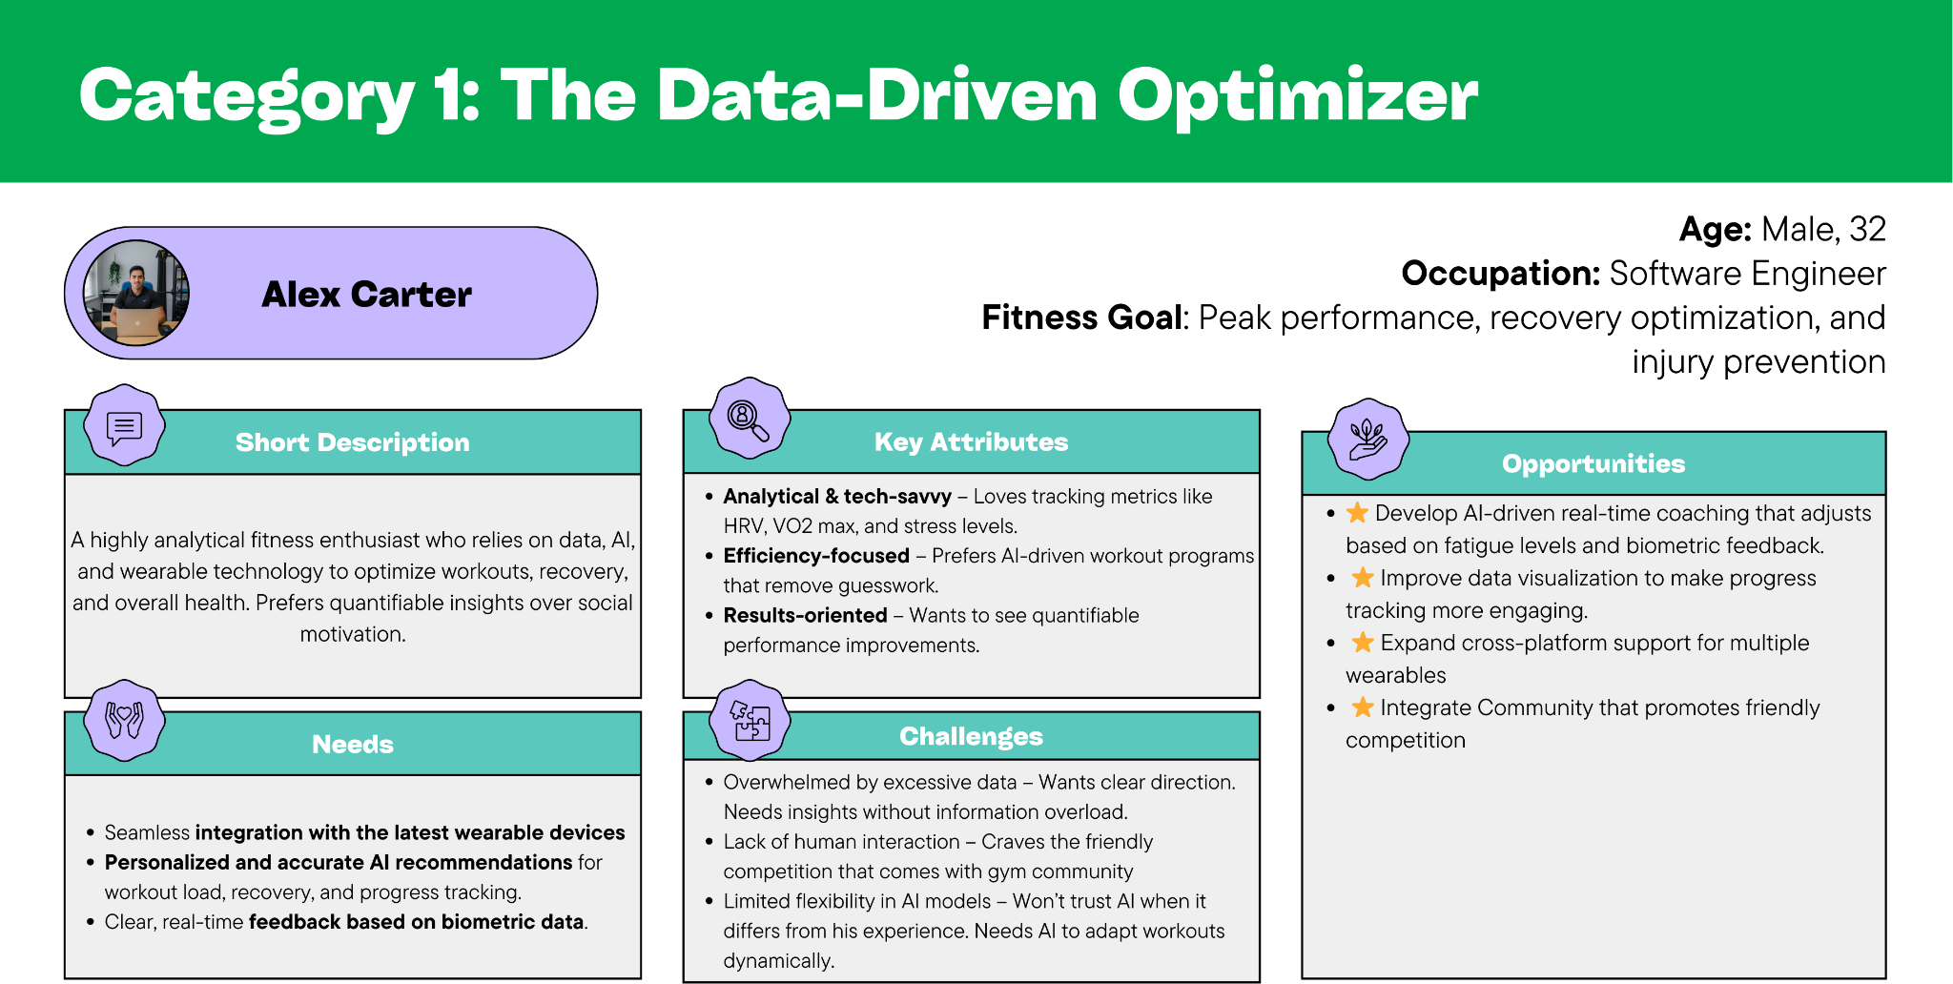
Appendix #1: Persona for Personal Data-Driven Performance Optimization Apps

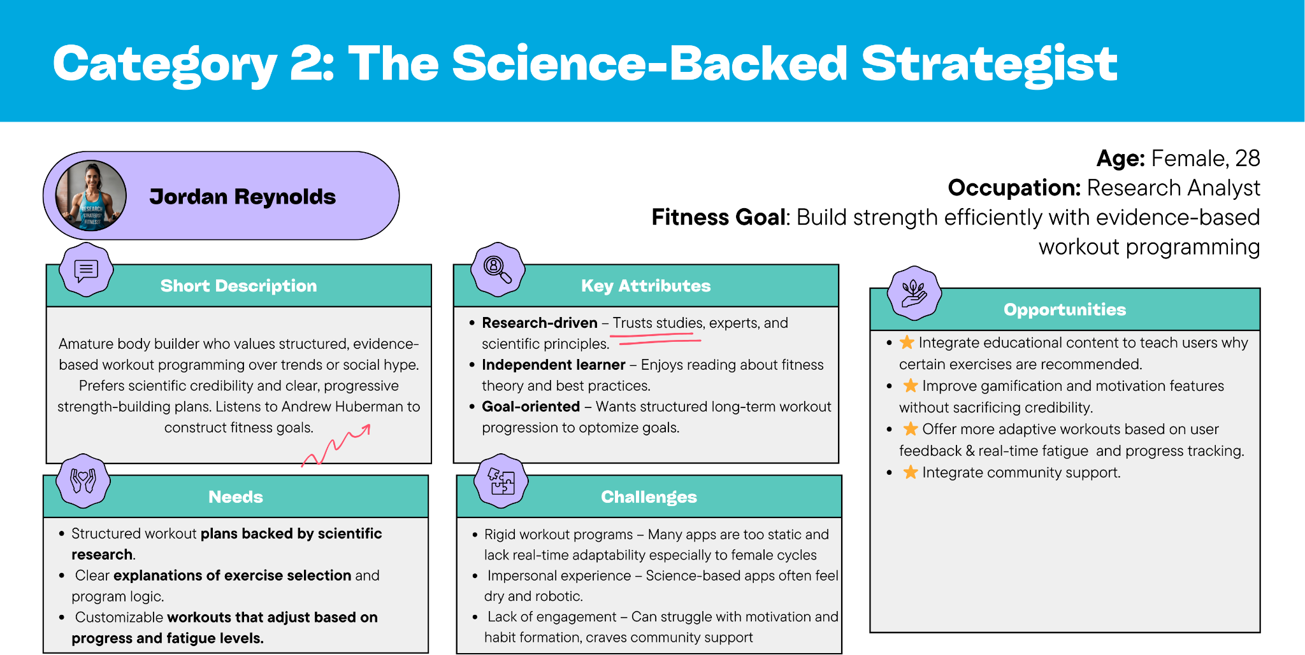
Appendix #2: Persona for Science-Based Workout Structuring Apps

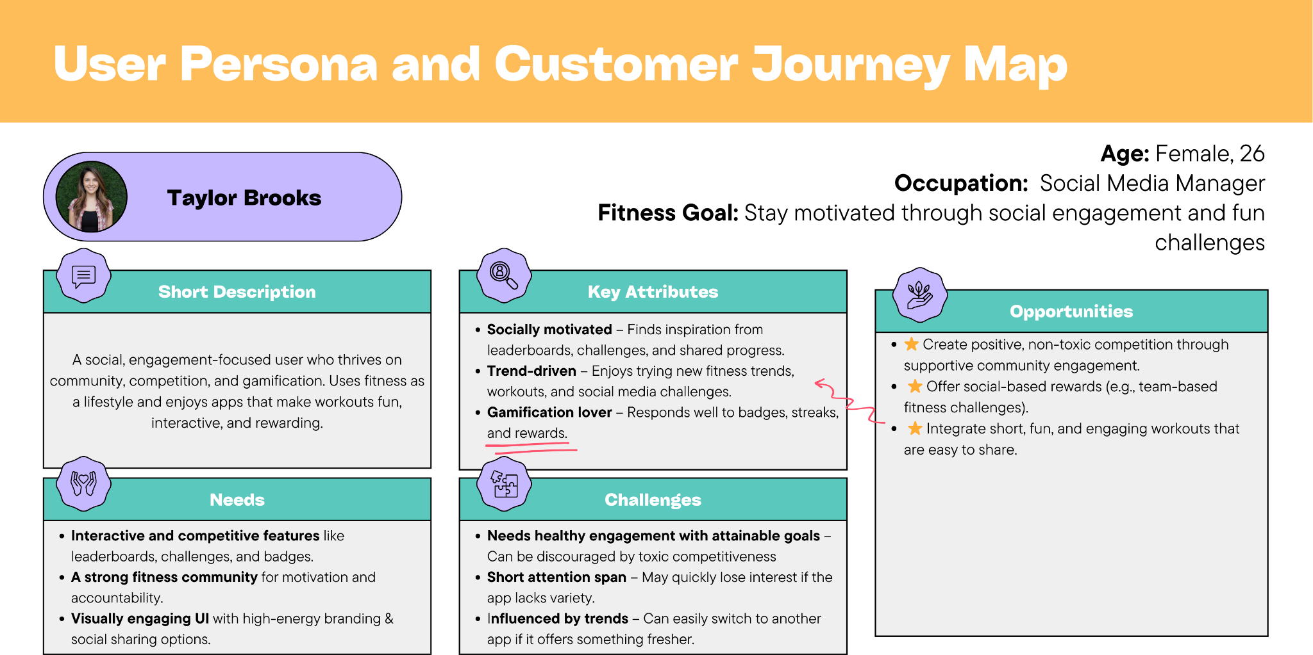
Appendix #2: Persona for Community & Lifestyle-Oriented Apps

